7 Join SQL Queries using all 3 tables

1 Retrieve properties from table1 that have a higher price per square foot than the average price per square foot in table2.

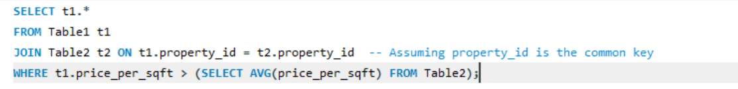

2 Find the properties in table1 that are located in cities where the average price per square foot in table2 is higher than the overall average price per square foot.

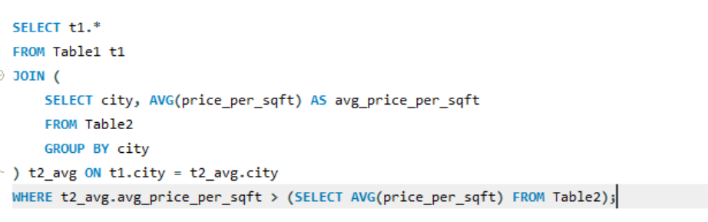

3. Retrieve properties from table1 with a certain landmark that have a lower price per square foot than the average price per square foot for properties with the same landmark in table2. (Choose landmark on our own)

4 Retrieve properties from table2 with a price per square foot higher than the average booking amount in table3

5 Count the number of properties in table2 with more bedrooms than the maximum number of bedrooms in table3

6

Find the cities where the average booking amount in table3 is higher than the overall average booking amount, and retrieve properties from table1 located in those cities

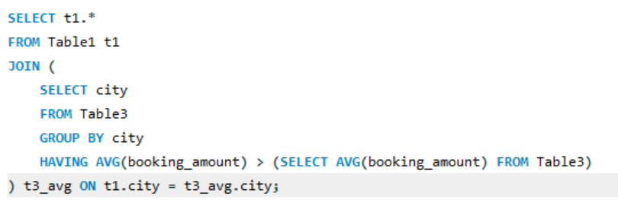

7

Retrieve properties from tablel with a furnished status of 'Unfurnished' and a facing direction that does not exist in table3.

